Exercises
For CICS programming

Table of Contents

I) Exercise I 2
1), sign on CICS. 2
1.1) 2
1.2) 3
1.3) 4
2), CEOT: terminal status transaction. 5
2.1) 5
2.2) 6
3), CEMT: master terminal transaction. 7
3.1 7
3.2 9
3.3 11
3.4 13
3.5 15
4), CEBR: temporary storage browsing transaction. 17
4.1 17
4.2 18
5), CEDA：resource definition online transaction. 19
5.1 19
5.2 22
5.3 25
6), CESF: sign-off CICS: 27
6.1 27
6.2 28
II) Exercise II 29
III) Exercise III 31

I) Exercise I

Exercising for CICS supported transactions

1), sign on CICS.

1.1)
Please enter ‘LOGON APPLID(CICSACB2)’.

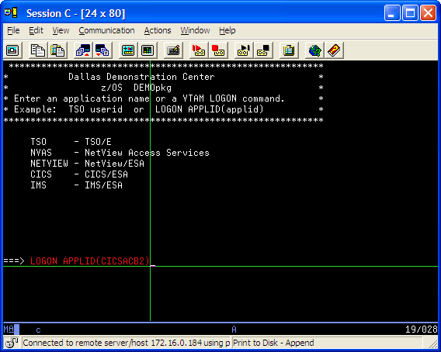

1.2)
You will see the following after entering.

Please enter your Userid and Password, then enter:

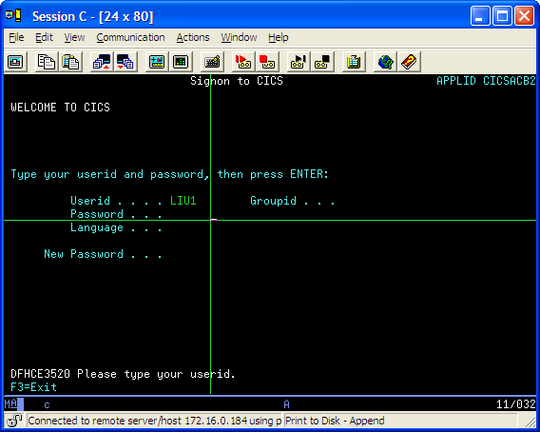

1.3)
the following is displayed after entering.

You have signed on CICS successfully.

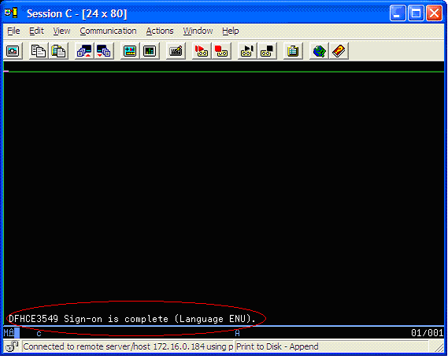

2), CEOT: terminal status transaction.

2.1) please entering ‘CEOT’.

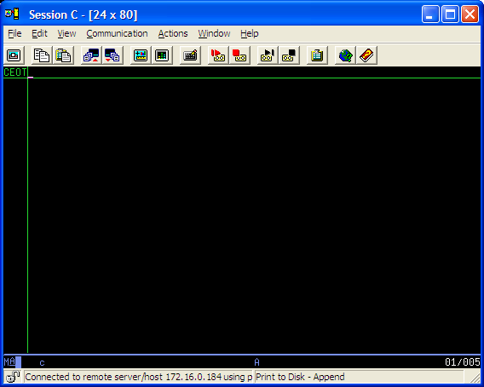

2.2) the following is displayed after entering.

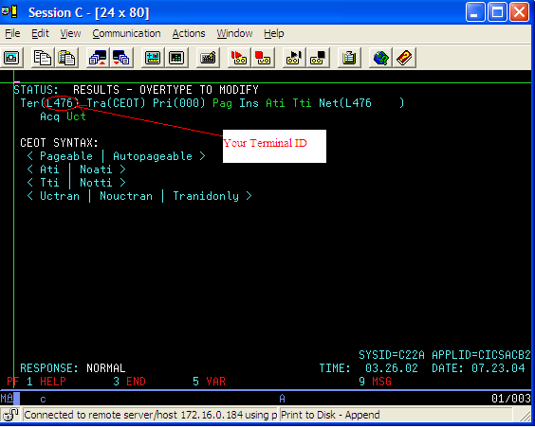

3), CEMT: master terminal transaction.

3.1), Inquiring the programs.

3.1.1) Please enter ‘CEMT I PROGRAM(*)’

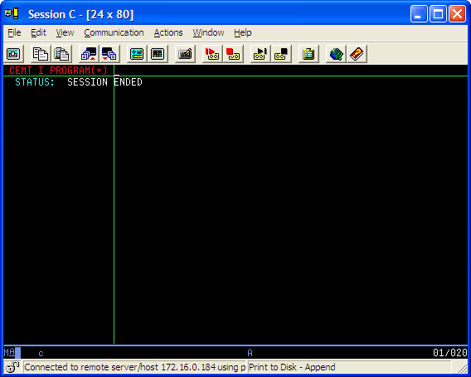

3.1.2), the following is displayed after entering.

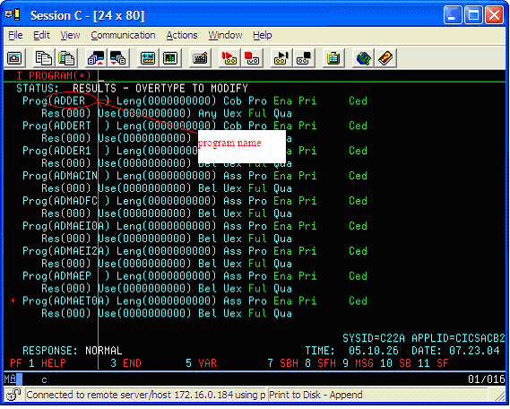

3.2), Inquiring the transactions.

3.2.1), Please enter ‘CEMT I TRAN(*)’.
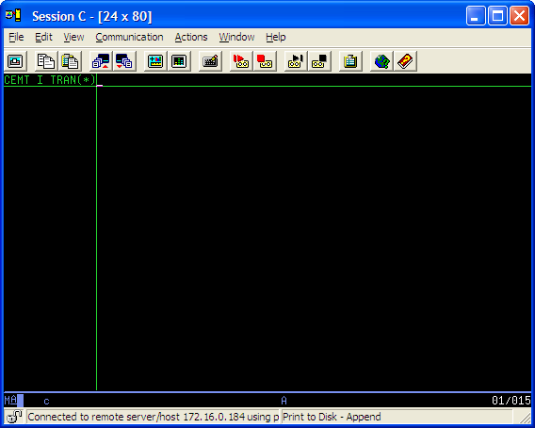

3.2.2), the following is displayed after entering.

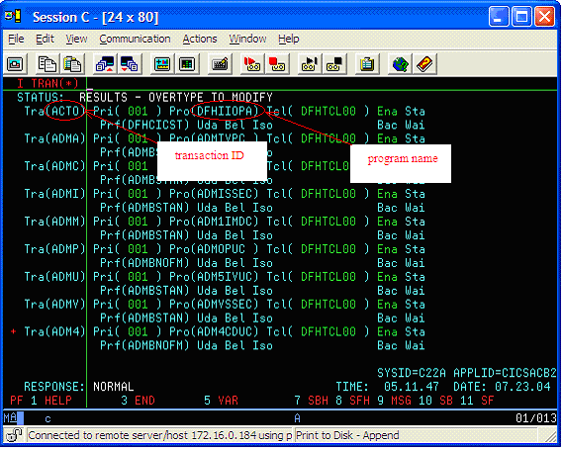

3.3), Inquiring the task.

3.3.1), please enter ‘CEMT I TASK(*)’.

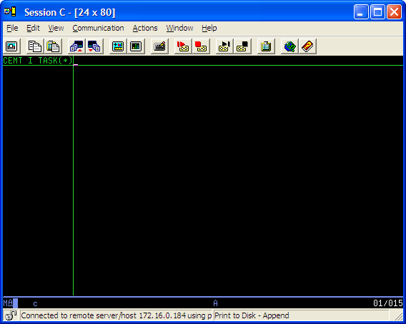

3.3.2), the following is displayed after entering.

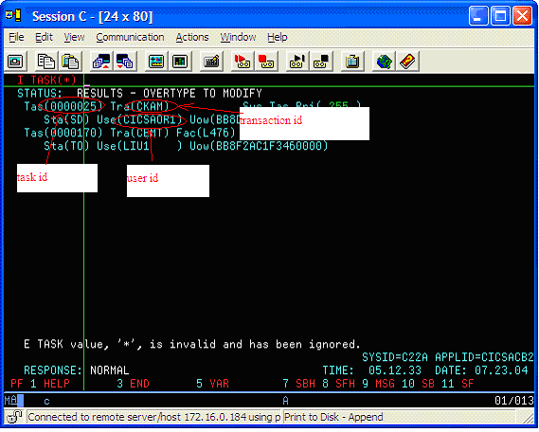

3.4), Inquiring the files.

3.4.1), please enter ‘CEMT I FILE(*)’.

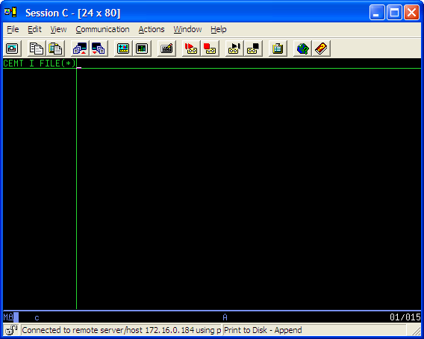

3.4.2), the following is displayed after entering.

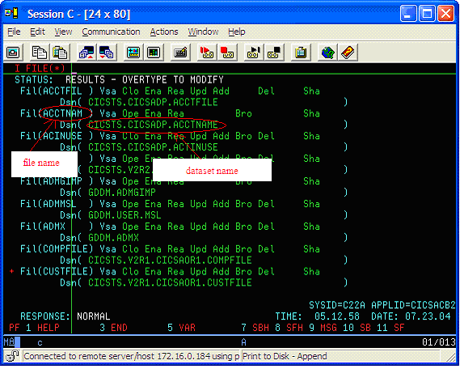
3.5), Inquiring the terminals.

3.5.1) please enter ‘CEMT I TER(*)’.

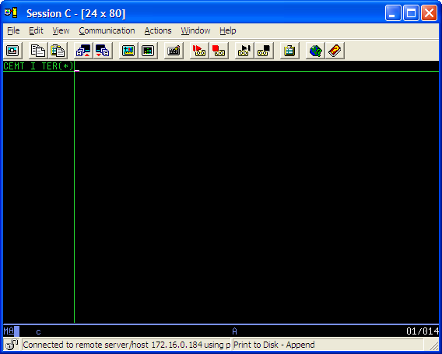

3.5.2), the following is displayed after entering.

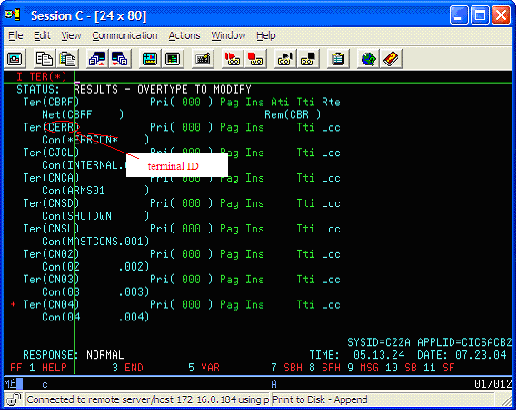

4), CEBR: temporary storage browsing transaction.

4.1), please enter ‘CEBR’

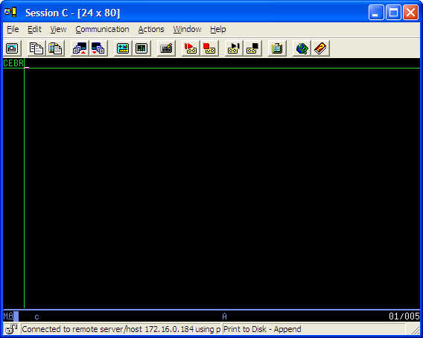

4.2), the following is displayed after entering.

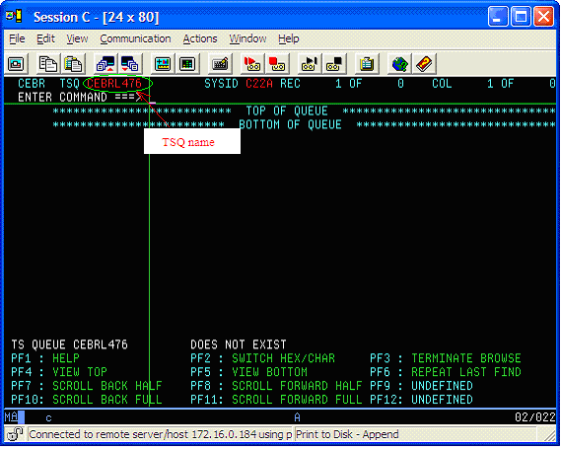

5), CEDA：resource definition online transaction.

5.1) define a program.

5.1.1) please enter ‘CEDA DEF PROG’.

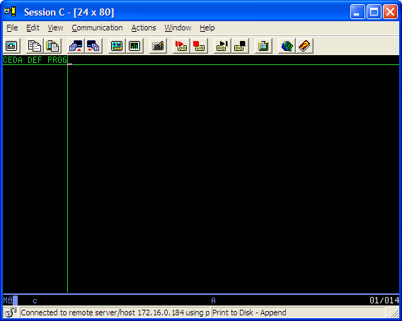

5.1.2), the following is displayed after entering.

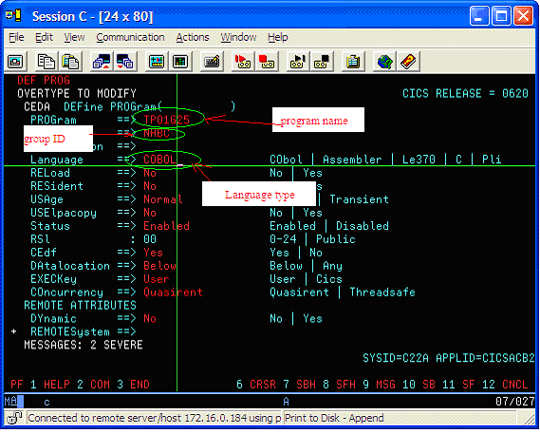

5.1.3), the following is displayed after entering.

The program has been defined successfully.

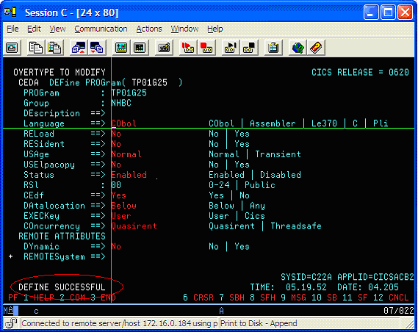

5.2) define a transaction.

5.2.1) please enter ‘CEDA DEF TRAN’.

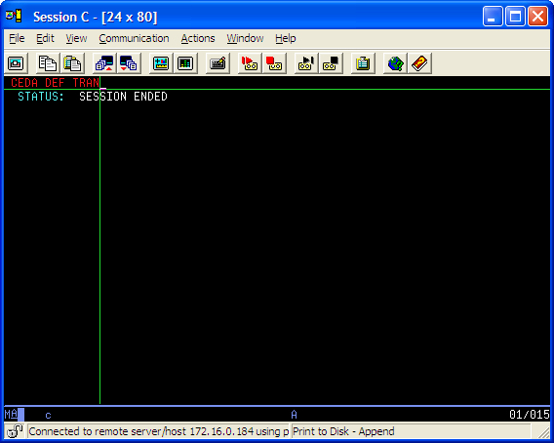

5.2.2), the following is displayed after entering.

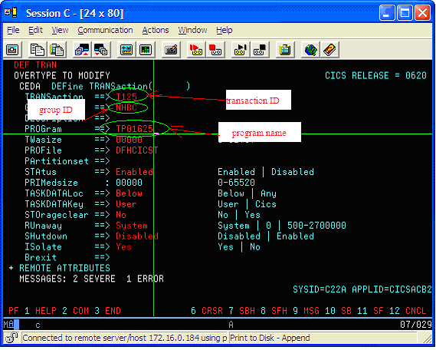

5.2.3), the following is displayed after entering.

The transaction has been defined successfully.

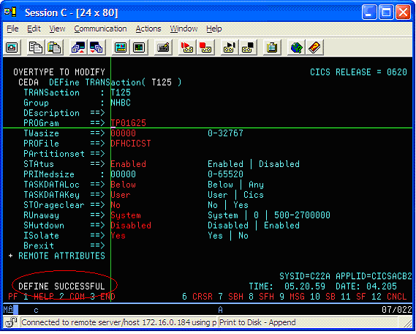

5.3) install a resource group.

5.3.1), please enter ‘CEDA INSTALL GROUP(NHBC)’.

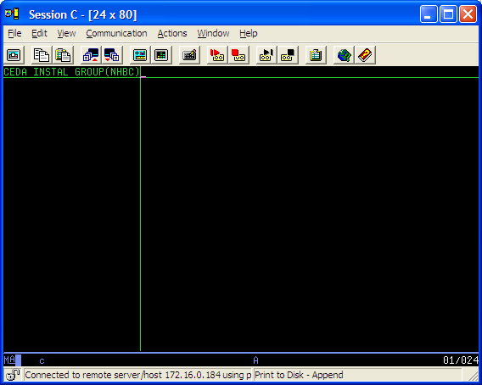

5.3.2), the following is displayed after entering.

The group has been installed successfully.

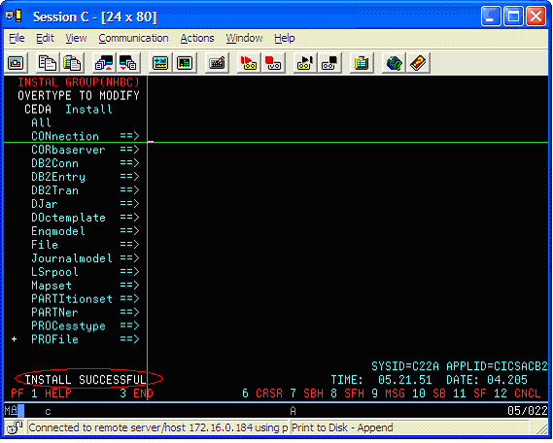

6), CESF: sign-off CICS:

6.1), Please enter the Command : CESF LOGOFF

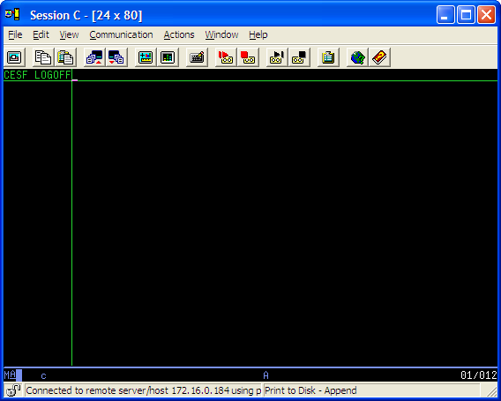
6.2), the following is displayed after entering:

the CICS has been signed off successfully.

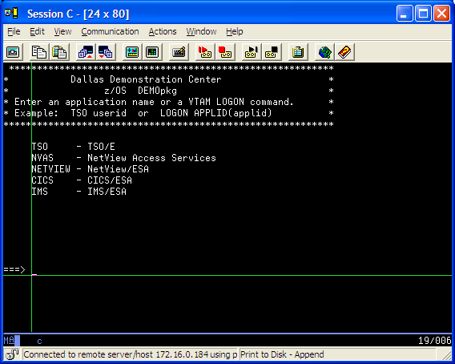

Exercise II

Program name: TP01GXX (XX--group ID. Example: Group 25—TP01G25)

Transaction name: T1XX

Program function:

a), receiving input from terminal;

b), send the text ‘ hello XXX!’ to the terminal; (XXX—input values)

You must do as following:

a), coding the program.

b), compiling and linking the program.

c), define the resource of CICS for your program using CEDA transaction,

such as program, transaction and group.

Example for running:
1) receiving the text ‘LIUYONGPING’ from the terminal:
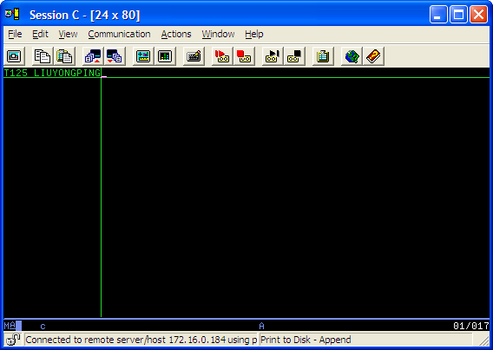

2) the result of sending to the terminal:
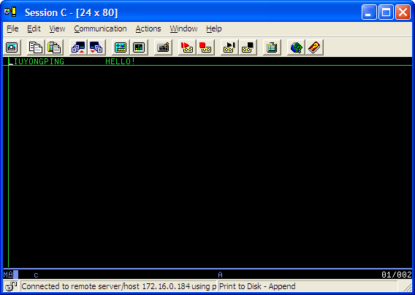

III) Exercise III

Program name:TP02GXX

Transaction name: T2XX

Program function:

a), Receiving input from terminal;

b), Read file ACCTNAM using the input as the key;

c), Send the result of reading to terminal;

you must do as following:

a), coding the program.

b), compiling and linking the program.

c), define the resource of CICS for your program using CEDA transaction,

such as program, transaction and group.

Example for running:
1) receiving the text ‘LIUYONGPING’ from the terminal.
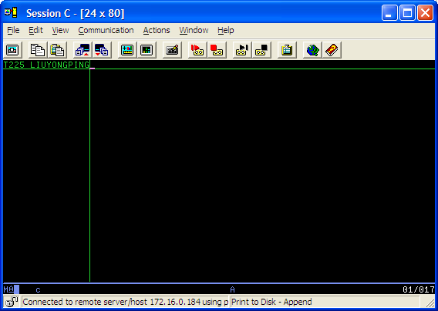

2) sending it to the terminal that the result of reading from file ACCTNAM 